The 2019 EP Election in Denmark: A European Election within a National Contest

Henrik Bech Seeberg (Department of Political Science, Aarhus University)
James Wilhelm (Vienna Center for Electoral Research, University of Vienna)

Version: 26 December 2019

Book chapter for “Assessing the 2019 European Parliament Elections“, edited by Sylvia Kritzinger, Carolina Plescia, Kolja Raube, James Wilhelm and Jan Wouters. Routledge.

- Introduction

The 2019 EP Election in Denmark took place on 26 May 2019, 10 days prior to the national election to the Danish Parliament on 5 June 2019. The incumbent right-wing Prime Minister, Lars Løkke Rasmussen, called the national election with four weeks’ notice, when the EP election campaign was already running at full speed. Hence, it could be that the EP Election was completely swamped by the national election as a ‘second-order election’, or that it was an important democratic event in its own right for Danish parties and voters, i.e a ‘first-order election’.
The immediate implication of the coincidence of the national election campaign with EP election campaign was that only EP candidates campaigned explicitly on the EP Election. The party leaders were preoccupied with the national election and ‘local’ problems took center stage, such as whether the government should allow refugees in the ‘Sjælsmark Immigrant Center’ to access a kitchen to cook their own meals and whether the government should set up an immigrant deportation center on the small island of Lindholm. Moreover, the incumbent Prime Minister, Lars Løkke Rasmussen, hijacked the national campaign by proposing a cross-bloc coalition government with the Social Democrats – which made the national campaign very distant from Brussels. Yet, at the same time, since voters were concerned with cross-border issues such as the environment/climate and immigration, the EU and its role with respect to these issues became a natural point of discussion, also in the national campaign (Beach et al. 2018). Hence, despite much media coverage in Denmark of Brexit and the British negotiations with the EU, the EP election shared a focus on actual policy problems with the national campaign rather than being a discussion on the merits of the EU as such. Moreover, despite the Eurozone crisis in present memory, debate did not focus on the euro or the banking union.
Part of the reason why the campaign was not focused on the merits of the EU as such was probably that there is no true/dedicated, vocal Eurosceptic party in Denmark. The radical left party, the Red-Green Alliance, is the most critical voice against the EU together with the radical right party, the Danish People’s Party (Kölln and Seeberg 2019). These two parties are antagonistic in all policy areas other than the European integration, yet it is important to note that the level of Euroscepticism of neither party comes anywhere near close to that of, for example, the British Brexit party. In terms of party competition, this creates some odd bedfellows because two antagonists on opposite sides of the political spectrum would have to team up to form an anti-EU alliance, and the mainstream centre-right and centre-left would have to join forces as to form a pro-EU coalition (together with the Social Liberals). Hence, party competition on the EU issue is generally absent in Denmark. Outside EU referenda, the EU issue receives very little attention (Green-Pedersen 2012; Senninger 2017). This was also the case in the 2019 EP election. Moreover, despite the Danish Commissioner for Competition and Trade, Margrethe Vestager’s candidacy to head the European Commission, the European ‘Spitzenkandidaten’ contest – to potentially become President of the next European Commission – was only a minor issue in the EP election campaign in Denmark.
Despite this general lack of interest in the EU among the parties in the Danish parliament, several of the larger parties were represented by highly popular and very well-known candidates. Among the 14 Danish seats to the European Parliament, the top four candidates each received close to 200,000 personal votes (almost 10% of the votes) – this is highly unusual in Danish national elections where, for instance, the incoming Prime Minister, Mette Frederiksen, and the exiting Prime Minister, Lars Løkke Rasmussen, each received only around 40,000 personal votes in the national election. Hence, voters probably relied heavily on the candidate gallery as a heuristic to make up their mind in the EP election. Finally, the 2019 EP Election in Denmark will be remembered for its historically high turnout of 66% – even if this still falls far short of the usual turnout at national elections of around 85%.
Hence, a key question for analysis is to what extent the 2019 EP Election in Denmark was a first-order or a second-order election, unusually embedded as it was within the 2019 national election campaign. To answer this question, we draw on new data from the RECONNECT 2019 EP election citizen-level survey to shed light on Danish voters’ interest in the EP election, their issue priorities, and voting behaviour.

- Attitudes towards EU membership in a long-term perspective

Despite a series of referenda on EU matters that may suggest otherwise – the initial rejection of the Maastricht Treaty in 1992 (50.7% against), the rejection of the euro membership in 2000 (53.2% against), and a vote against the proposal to amend Denmark’s full opt-out on justice and home affairs matters to a more limited arrangement in 2015 (53.1% against) – Figure 1 provides a relatively positive view of Danish citizens’ attitudes towards their country’s membership of the EU. The historical trend line shows whether Eurobarometer respondents in Denmark think that their country’s membership of the European Union is a “good thing”, a “bad thing”, or “neither a good thing nor a bad thing” during the time period 1991 to 2019. From a low point of respondents describing Denmark’s membership of the EU as a “good thing” in 1997 (45%), the general trend has been towards an increase in the share of respondents in this category and a simultaneous decrease in those responding that Denmark’s membership of the EU is a “bad thing”. Amongst other factors, this trend may be explained by the gradual recognition that the European Union is a market-regulating as well as a market-making actor, making the EU more palatable to citizens in a coordinated market economy such as Denmark. For example, the Socialist People's Party began to change its stance towards the EU to a more favourable one towards the end of the 1990s, indicating the gradual softening of opposition towards European integration as a threat to the Danish economic model (though some opposition still persists).
Perhaps unsurprisingly, the most marked dip in the trend line, 2011, coincides with the onset of the financial crisis. Though its consequences were not as severe in Denmark as in Greece, Italy or Spain, it still led to a sharp spike in unemployment in Denmark, from around 2.5% in 2008 to 6% by 2010. This appears to have been taken into account in Danish respondents’ evaluations of their country’s EU membership, reflecting a more general trend across Europe at the time, including a general downturn in national government evaluations (Armingeon and Ceka 2013). However, positivity towards Denmark’s EU membership almost entirely rebounded to pre-crisis levels by June 2013.
It is notable that the general increase in the percentage of respondents referring to Denmark’s EU membership as a “good thing” appears uninterrupted by the 2015/2016 migration crisis (or, at least, did not lead to a decline in support for EU membership), despite this leading to the reintroduction of border controls in Denmark – controls that are still in place in 2019. It may in fact be that this flexible response to the crisis – the introduction of temporary controls – tempered any associated tendency towards a decline in support for EU membership. For the most recent time point, February 2019 (three months prior to the EP election), the percentage of respondents who said that Denmark’s membership of the EU is a “good thing” in fact reached its highest point for the time period studied (77%) and, conversely, those responding “bad thing” its lowest point (8%). This coincides with a collapse in support for the right-wing, anti-immigration Danish People’s Party in the 2019 Danish general election (from 21% in 2015 to 9% in 2019) on June 5, suggesting that this upswing may be linked to the slow decline in the overall salience of the immigration issues in Denmark.
All this suggests that despite the impression of Denmark as a Eurosceptic country that can be gleaned from rejection of several pro-integrative measures via referenda in recent decades, Danish citizens have in fact become increasingly positive about EU membership over time – beginning shortly after the EU’s policy-making turn towards market regulation during the 1990s. And even before this upswing, support of Danish citizens for EU membership outweighed opposition. Despite some media commentary about the possibility of a Danish exit from the EU (a so-called ‘Dexit’), the data presented here suggests that such a possibility is now more unlikely than ever, and support for EU membership was at a historic high just months before the European Parliament election 2019 in Denmark on May 26 2019.

Figure 1: Over time support for European unification, according to eligible Danish voters
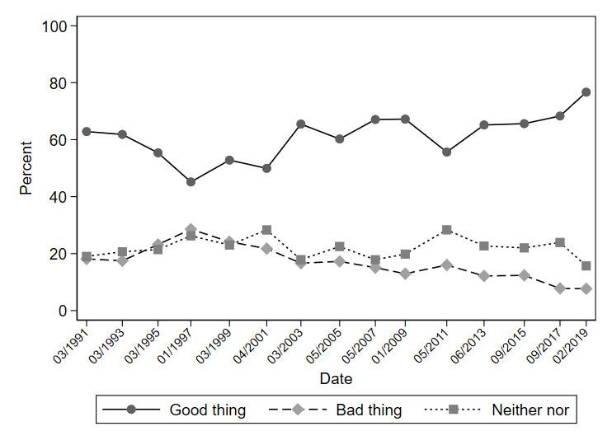
Source: Eurobarometer 1990-2019. Question wording “Generally speaking, do you think that Denmark’s membership of the EU is ...?”

Figure 2 presents turnout levels in national and EP elections in Denmark in long-term historical perspective. Turnout in the 2019 EP election in Denmark in fact hit an all-time high for EP elections held previously, with 66% of eligible voters turning out to vote, an increase of 10 percentage points over 2014 (56%) and 6% over the previous highest turnout level in 2010 (60%) (see Figure 2). One possibility is that the spike in turnout in 2019 resulted from a particularly first-order European election, with high levels of voter engagement in the EP election campaign itself. However, it is worth reiterating that a special feature of the 2019 EP election in Denmark was that the Danish general election took place on June 5 2019, just 10 days after the EP election, resulting in the latter becoming almost entirely embedded within the national campaign. As Reif and Schmitt (1980) emphasise, a major determinant of EP election turnout is its placement within the national electoral cycle, while Franklin (2001) contends that EP elections held just before a national election should result in higher turnout, with such elections effectively treated as a “barometer” for the upcoming national contest. As such, the historically high turnout in the 2019 Danish EP election may have been generated not because European issues and topics became particularly salient for voters, but because it was perceived to be a test run for the upcoming national contest, i.e a second-order effect.
What is more certain is that despite reaching a historical high of 66% for EP elections, recorded turnout in the 2019 EP election in Denmark still fell short of the 85% turnout recorded for the national election just 10 days later – and, in fact, short of turnout in any Danish post-war national election, which has not dipped below 80%. This strongly suggests that voters in general felt less was at stake in the EP election contest than is typically the case in a national one – a hallmark of second-ordernesss.

Figure 2: Historical turnout in European Parliament and national elections in Denmark
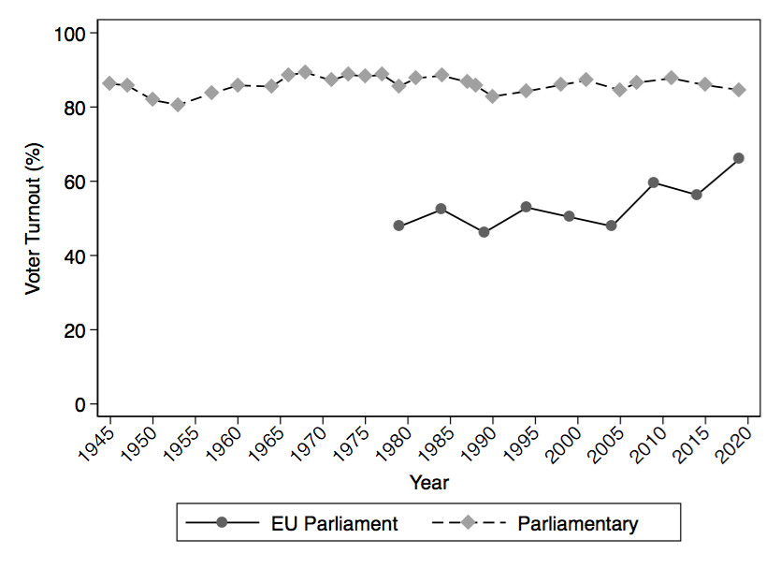
Source: IDEA Turnout Data Base

- EP election engagement or national influence?

To shed further light on the nature of voter engagement in the 2019 EP election in Denmark, Figure 3 displays the level of interest of respondents in both politics generally (pre-campaign) and the European Parliament election specifically (pre- and post-campaign). The individual-level data was collected before and after the EP election campaign as part of the RECONNECT citizen-level survey. Respondents’ general interest in politics was tapped with the question “Generally speaking, how interested are you in politics?”, and interest in the EP election with “And how interested are/were you in the upcoming/recent European Parliament election?” For both questions, respondents could choose between the response options “very interested”, “fairly interested”, “a little interested” and “not at all interested”.
Figure 3 reveals that general interest in politics, measured before the campaign started, substantially exceeded interest in the European Parliament election, either before the campaign began or after it had run its course. Concretely, 64% of respondents reported being either “very interested” (19%) or “fairly interested” (46%) in politics generally (measured pre-campaign), whereas only 43% of respondents reported having the same interest level in the European Parliament election before the campaign started (10% “very interested”; 33% “fairly interested”) and a slightly higher 44% after the campaign was complete (10% “very interested”; 34% “fairly interested”). In other words, against the benchmark of general political interest, the European Parliament election fell short, indicating a degree of second-orderness in terms of voter attention.
Figure 4 takes this analysis one step further, this time directly comparing how closely respondents in the RECONNECT survey reported following the EP and national campaign, measured directly after EP Election Day (i.e. also deep into the national election campaign – just 9 days before the election itself). In separate questions, respondents were asked “How closely did you follow the recent European Parliament election?” and “…how closely have you been following the national election campaign to elect representatives to the Folketing, taking place in June 2019?” The available response options for both questions were “very closely”, “fairly closely”, “a little” and “not at all”. Results reveal that while 62% of respondents reported following the national election campaign “very” or “fairly” closely (19% and 44%), only 43% reported following the EP election campaign as closely (8% “very” and 35% “fairly” closely). Moreover, more than twice as many respondents reported following the national election “very closely” (19%) than did so for the EP election campaign (8%). Though Figure 3 and Figure 4 do indicate that a large number of voters were interested in the EP election campaign – slightly short of half of survey respondents reported following the campaign “fairly” or “very closely”, and a similar share was “fairly” or “very” interested in the election – it is clear that the national election was markedly more successful in generating voting interest.

Figure 3: Interest in politics (pre-election) and the European Parliament election campaign (pre- and post-election)
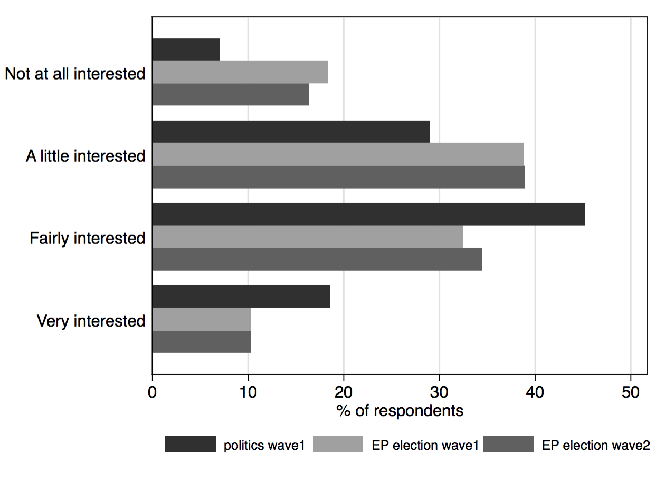
Source: RECONNECT 2019 European election survey data. Fieldwork period: Pre-election wave, April 2-19 2019; Post-election wave, May 27-June 24 2019.

Figure 4: Closeness of following of EP and national election
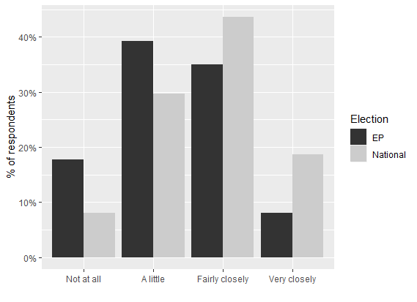
Source: RECONNECT 2019 European election survey data. Fieldwork period: May 27-June 24 2019.

Another way to shed light on whether turnout was driven by engagement with the EP election campaign itself is to analyse the issues that were important to voters. Figure 5 plots this information for respondents taking part in the RECONNECT EP election survey, pre- and post-campaign. Respondents were able to select one issue as the “most important” issue “facing Denmark today” from those listed in Figure 5. Notably, both before and after the campaign, no more than 3% of respondents selected either European integration or the Euro as most important, and the percentage of those selecting this category increased only slightly from the pre- to post-election period (2% to 2.1%). That both of these issues failed to ‘bite’ for Danish voters – despite an EP election campaign – reflects a general absence of political attention among Danish parties to genuine EU issues (Green-Pedersen 2012). Concerning the two issues that were clearly most frequently selected as most important by respondents both before and after the campaign – environment/climate change and immigration/asylum rules – it is difficult to assess whether this represents voter engagement with the European election campaign specifically. On the one hand, both issues are clearly transnational in scope, and thus arguably European issues, despite strong national competences in both policy areas. On the other hand, both were themes of the national election campaign, and it is thus difficult to distinguish whether the importance of these to voters represents engagement with issues pertaining to the national or European level, or both to some degree.

Figure 5: Most important issue facing Denmark, pre- and post-EP election

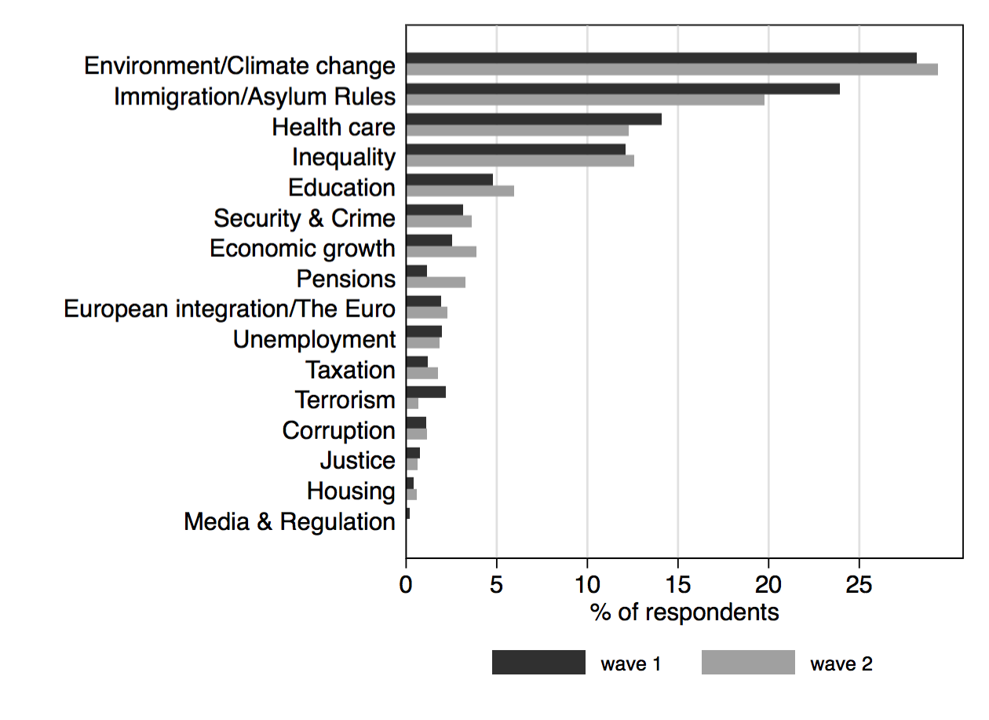
Source: RECONNECT 2019 European election survey data. Fieldwork period: Pre-election wave, April 2-April 19 2019; Post-election wave, May 27-June 24 2019.

To help shed further light on the extent to which Europe was salient to voters during the EP election campaign, Figure 6 reports on data collected as part of the RECONNECT citizen-level survey concerning political discussion. Concretely, respondents were asked “Which issue among the following did you discuss in the past month?”, with respondents able to select one of the European issues from those listed in Figure 6, or specify an alternative issue in text. Unlike the most important issue question, this question prompted respondents to report upon European themes specifically in their political discussion, and thus isolates this from the more generic issues reported upon in Figure 5.
Perhaps most tellingly, “Did not discuss EU politics” was the most commonly selected response option, both before and after the campaign had taken place (53% and 40% of respondents, respectively). This response option indicates not even minor discussion of European issues amongst 40% of respondents during the run-up to Election Day in the case of the post-election measure. Clearly, this level of disengagement with election issues falls well short of what would be expected in a first-order contest, though it is clear that the campaign did at least help to reduce the level of non-discussion of EU issues, with a 13 percentage point drop in respondents falling into this category by the end of the campaign. In terms of the topics discussed, it is notable that despite much elite level debate, only a very minor share of respondents ranked core EU issues relating to the competences of EU institutions, the single market and monetary union as most discussed. Notably, the most discussed substantive issue was Denmark’s membership of the European Union rather than any EU-level policy initiative or proposals for EU reform. Meanwhile, the campaign appears to have been most effective in promoting discussion of the election as an event, with a spike in the share of respondents naming “European elections 2019” as their most discussed topic, from 7% before the campaign to 21% afterwards. These results suggest that while the EP election campaign was successful in promoting increased discussion of European topics – even though fighting for voters’ limited attention within the context of a national campaign as well – this did not lead to ‘deep’ voter engagement with the key policy issues, and rather seems to have been most effective in raising the salience of the election as an event.

Figure 6: Most discussed European issues, pre- and post-EP election
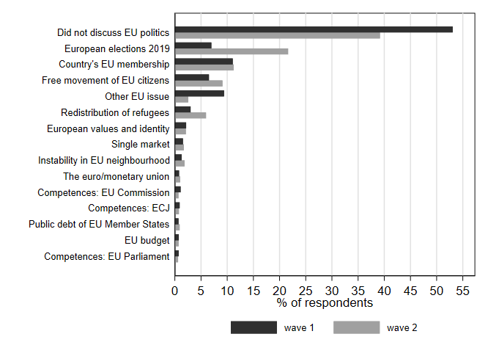
Source: RECONNECT 2019 European election survey data. Fieldwork period: Pre-election wave, April 2-19 2019; Post-election wave, May 27-June 24 2019.

Though there is little evidence to suggest that the EP election campaign fostered deep engagement with key European issues, was it successful in helping to crystallise broad differences in stances taken by Danish parties in relation to European integration? Figure 7 sheds light on this question on the basis of individual-level data from the RECONNECT citizen-level survey, mapping the mean position of major parties amongst Danish respondents (from top to bottom, the centre-right Venstre “V”, the Social Democrats “SD”, the far-right Danish People’s Party “O”, the far-left Enhedslisten “Enhe”, the Socialist People's Party “SF” and the Social Liberals “B”) both before and after the election campaign. Respondents were asked to place each party on a 0-10 European unification scale, where 0 indicates that unification has “gone too far” and 10 that it should be “pushed further”. Whiskers around the means plot twice the standard error.
Most strikingly, even before the campaign began, respondents already perceived major differences in party positions, perceiving the far-right Danish People's Party (O) and far-left Red-Green Alliance (Ø) to be Eurosceptic and the centrist Liberals (V), Social Democrats (A) and Social Liberals (B) to take pro-integration stances. The mean plus twice the standard error for any two parties drawn from either group does not overlap, indicating a ‘real’ perceived difference. At the same time, Figure 7 shows that although respondents perceived the Danish People’s Party and the Red-Green Alliance to be the most Eurosceptic parties in the Danish parliament (both before the campaign and after its conclusion), their mean placements are nowhere near the zero-point on the European unification scale. Hence, Danish voters do not perceive either party to be a true, niche party that is completely and fully opposed to the EU. Meanwhile, the more ambivalent Socialist People's Party, which initially strongly opposed European integration as a market-making project but has slowly shifted its position as the EU has turned towards a focus on market-regulation in recent decades, is perceived as between these two groups, both pre- and post-campaign.
The key campaign effect appears to be an increasing clarity of differences in party positions for those that were perceived to take clear positions before the campaign (except for the Socialist People's Party), indicated by the more polarized placements of parties after the campaign had run its course. Though the greater extremity increase for individual parties leading to greater polarisation overall is slight in most cases (so slight, in fact, that the mean plus twice the standard error does overlap in every case), the pattern is largely consistent, except for the Red-Green Alliance (Ø), where there is a slight movement towards the midpoint from a clearer perceived pre-campaign stance. This is indicative of at least some politicisation of European integration as the EP election campaign progressed – even if this may have also been generated in combination with the national election campaign.

Figure 7: Mean of respondents’ perceptions of Danish parties’ European unification positions, pre- and post-EP election
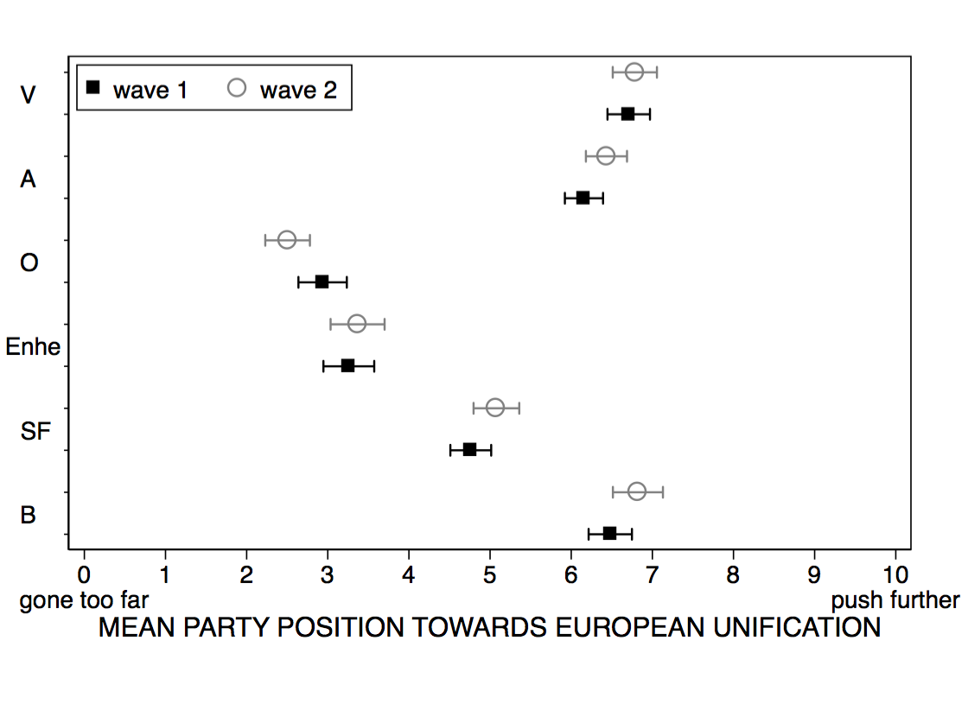
Source: RECONNECT 2019 European election survey data. Fieldwork period: Pre-election wave, April 2-19 2019; Post-election wave, May 27-June 24 2019. “V” is the Liberals, “A” is the Social Democrats, “O” is the Danish People’s Party, “Ø” is the Red-Green Alliance, “F” is the Socialist People’s Party, and “B” is the Social Liberals.

- Voting behavior in the 2019 EP election

Moving to the results of the 2019 European Parliament election in Denmark held on May 26, Table 1 presents the votes received by each of the competing parties, as well as comparative information in relation to the 2019 Danish general election, which took place on June 5 (i.e. 10 days afterwards), and the 2014 EP election. The election resulted in a large victory for both the major parties of the left and right, the Social Democrats and Venstre, which won 21.5% and 23.5% of the vote respectively (each winning 3 seats in the next European Parliament). Both easily eclipsed the party winning the third largest number of votes, the Socialist People’s Party, which received 13.2% of votes (winning two seats). Besides this, a major feature of the election was a collapse in the vote for the far-right, anti-immigration Danish People’s Party: its 10.8% vote share was almost 16 percentage points down on 2014, and the party is set to lose three of its four seats in the Parliament. This implosion can partly be ascribed to the fact that their previous top-candidate, Morten Messerschmidt, who received a whopping 400,000 personal votes in the 2014 EP Election, did not run for election this time; it can also in part be ascribed to the change in party leadership, with the hugely popular Pia Kjærsgaard, who established the party in 1995, stepping down in 2012 and effectively ruling herself out of a return to leadership when she was appointed Speaker of the Danish Folketing after the 2015 National Election. The upswing in the vote share for Venstre, the Social Democrats, the Socialist People's Party and the Social Liberals over 2014 suggests that these parties profited the most from this collapse. At the same time, the People's Movement Against the EU (which does not run for national election) received 3.7% of the vote, a drop in vote share of 4.4% over 2014. The poor performance of both the Danish Peoples’ Party and the People's Movement Against the EU, combined with simultaneous gains made by Venstre and the Social Democrats demonstrate that despite much talk of a Eurosceptic breakthrough across Europe in the run-up to the 2019 EP election, Denmark appears to provide evidence of this narrative running in reverse.

Table 1: Results of 2019 European Parliament election in Denmark
Parties and coalitions | EP group | EP votes (N) | EP votes (%) | Vote change from 2014 (%-points) | Seats  Total | Votes  (%) | Vote difference to NE
Venstre (V) | ALDE | 648,203 | 23.50% | +6.80% | 3 | 23,4% | -0.10%
Social Democrats (A) | S&D | 592,645 | 21.48% | +2.38% | 3 | 25,9% | +4.42%
Socialist People's Party (SF) | G-EFA | 364,895 | 13.23% | +2.23% | 2 | 7,7% | -5.53%
Social Liberals (B) | ALDE | 277,929 | 10.07% | +3.57% | 2 | 8,6% | -1.47%
Danish People’s Party (O) | ECR | 296,978 | 10.76% | -15.84% | 1 | 7,7% | -3.06%
Conservatives (C) | EPP | 170,544 | 6.18% | -2.92% | 1 | 6,6% | +0.42%
Enhedslisten (Ø) | GUE/NGL | 151,903 | 5.51% | N/A | 1 | 6,9% | +1.39%
People's Movement Against the EU (N) |  | 102,101 | 3.70% | -4.40% | 0 | N/A | N/A
Alternativet (Å) |  | 92,964 | 3.37% | N/A | 0 | 3,0% | -0.37%
Liberal Alliance (I) |  | 60,693 | 2.20% | N/A | 0 | 2,3% | +0.10%

Sources: European Parliament website (www.election-results.eu/denmark); Statistics Denmark (www.dst.dk).

On the face of it, these results do not seem to indicate a second-order election: in such elections, it is predicted that smaller and non-governing parties will tend to profit, with voters using the perceived lack of importance of the contest to vote ‘with the heart’, rather than to strategically affect the make-up of the future national government and parliament; and also to potentially send a signal of discontent to the national government, in the hope that this may lead to a change in policy at the national level (Hix and Marsh 2007). However, Venstre (V) and the Social Democrats (A), the two biggest winners in the 2019 Danish national election held 10 days after the EP election (the former also the largest party in Denmark’s governing coalition running up to the election), also won the most votes in the EP election. Meanwhile, there is little evidence in general of a surge in support for smaller parties relative to the national election (the largest positive difference is +1.5%-points for Enhedslisten), or non-governing parties (the largest difference is +4.4%-point for the Social Democrats). However, the theory of second-orderness appears to be in need to adaption to the Danish context: the theory’s major expectations were developed assuming the ‘normal’ scenario of an EP election taking place in the middle of a national electoral cycle, not within two weeks of a national election. In such a scenario, Franklin (2001) suggests that the EP election may become a “barometer” for the upcoming national contest (and thus secondary to it). Given this, an indication in the voting patterns that the Danish EP election was second-order would be if vote choice between the EP and subsequent national election are largely the same, suggesting that, despite differences in the characters of the elections and the issues at stake, the EP election failed to distinguish itself from the national election campaign in which it was embedded.
To what extent was this the case? Referring again to the election results in Table 1, a comparison of vote difference between the nine parties that stood in the EP election and then again ten days later in the general election shows that none received a vote share in the EP election that was six percentage points different to the general election. Moreover, for five of the nine parties, the share of the vote received in the EP election was within two percentage points of that received in the general election, and for three of the nine parties, within one percentage point. Thus, despite small differences, election results are consistent with broadly similar voting patterns in EP and general election.
However, aggregate level voting patterns may mask differences in voting between the national and EP election at the individual level. To provide insight at the individual level, Table 2 presents how respondents taking part in the RECONNECT EP election survey reported voting in the EP election and also, prospectively, in the upcoming national election. Descending the cells diagonally from left to right tracks the percentage of respondents who reported voting for the same party in both elections. Clearly, there is a high degree of consistency: for all except two parties (Enhedslisten and Liberal Alliance) did less than 30% of respondents report planning to vote for a party in the national election that was different from their vote choice in the EP election, and this share of respondents was below one-fifths in the case of Venstre (87.4%), the Social Liberals (83.1%) and the Conservatives (81.8%). In other words, for most parties, respondents were more likely than not to report voting for the same party in the EP election as in the national election.
Nevertheless, there is evidence of important differences in voting behavior in the EP election. For respondents whose vote intention was for Enhedslisten and Liberal Alliance in the national election, there appears to be a tendency to vote for larger parties of a similar ideology in the EP contest: almost 38% of prospective Liberal Alliance voters in the national election reported voting for Venstre in the EP contest and almost 18% for the Socialist People's Party (SF); and almost one-fifth of respondents intending to vote for the far-left Enhedslisten (Ø) in the national election reported a vote for the Socialist People's Party (SF) in the EP election. Another notable difference: almost 14% of respondents who reported voting for the Conservatives (C) and 23% for the Danish People’s Party (O) in the national election reported voting for the more pro-EU Venstre (V) in the EP election. There is also a strong tendency for respondents not voting for a party listed in Table 2 doing so in the EP election, with a heterogeneous mix of Venstre (23.1%), Conservatives (21.7%) and the Danish People’s Party (16.9%) appearing to benefit from this. Thus, although a correspondence between national and EP vote choice is most common amongst respondents, there is also evidence of some divergence, suggesting that the EP election was at least partially successful in distinguishing itself from the national campaign.

Table 2: Consistency between vote choice in national and EP election
 | EP election, May 26 2019
National election,  5 June 2019 | A | O | V | Ø | I | B | SF | C | Other party
Social Democrats  (A) | 73.2% | 5.0% | 5.2% | 0.6% | 0.0% | 2.7% | 7.4% | 5.8% | 0.0%
Danish People’s Party  (O) | 0.0% | 74.3% | 23.0% | 0.0% | 0.0% | 0.0% | 1.3% | 1.3% | 0.0%
Venstre  (V) | 1.6% | 3.2% | 87.4% | 0.0% | 0.4% | 0.0% | 0.2% | 7.1% | 0.0%
Enhedslisten  (Ø) | 6.4% | 1.4% | 7.2% | 51.5% | 0.0% | 1.4% | 19.3% | 10.5% | 2.3%
Liberal Alliance  (I) | 0.0% | 4.2% | 37.9% | 0.0% | 35.3% | 0.0% | 17.7% | 4.8% | 0.0%
Social Liberals (B) | 5.7% | 0.0% | 4.3% | 0.8% | 1.2% | 83.1% | 3.1% | 0.7% | 1.2%
Socialist People's Party (SF) | 14.0% | 4.4% | 0.0% | 3.2% | 0.0% | 4.7% | 70.8% | 2.9% | 0.0%
Conservatives (C) | 0.0% | 4.3% | 13.9% | 0.0% | 0.0% | 0.0% | 0.0% | 81.8% | 0.0%
Other party | 3.3% | 16.9% | 23.1% | 2.1% | 0.7% | 6.9% | 9.9% | 21.7% | 15.6%

Source: RECONNECT 2019 European election survey data. Fieldwork period: May 27-June 24 2019. A darker shade is applied to cells indicating the same party choice between elections.

So far, differences in voting between the national and EP election have been analysed. To shed more light on the second-orderness of the 2019 EP election in Denmark, Table 3 tests a core expectation of second-order theory: that voting behaviour in EP contests will in part reflect a concern with the non-EU level, ‘secondary’ issue of national government performance, with dissatisfied individuals using the EP contest to send a signal to the national government by voting for non-governing parties (Hix and Marsh 2007). To the extent that this occurs, the EP contest is used by voters as leverage to influence national politics, rather than EU policy-making. Of the six parties listed in Table 3, Venstre led the governing coalition in the run up to the 2019 EP election, enjoying parliamentary support from the Danish People’s Party. Thus, second-order theory would predict that there should be a tendency for those dissatisfied with national government performance to vote against these two parties in favour of non-governing parties; and for those satisfied with the government to more strongly support governing parties.
Table 3 clearly supports this expectation: 62.5% of respondents who reported satisfaction with national government performance voted for either Venstre (48.5%) or the Danish People’s Party (14%). Meanwhile only 11.9% of those who were dissatisfied voted for one these two parties: 4.8% for Venstre and 7.1% for the Danish People’s Party. Conversely, only 22.3% of respondents reporting satisfaction with national government performance reported voting for one of the four listed non-governing parties (Social Democrats 14.3%; Enhedslisten 0.8%; the Social Liberals 2.9%; Socialist People’s Party 4.3%), while 75.2% of dissatisfied respondents reported doing so (Social Democrats 30.5%; Enhedslisten 10.1%; the Social Liberals 14.6%; Socialist People’s Party 20%). In other words, typical of a second-order election, there is a clear link between respondents’ evaluations of national politics, on the one hand, and vote choice in the European election, on the other. Of course, this link could reflect vote choice influencing performance evaluations as much as the other way around. Nevertheless, it is unlikely that EP vote choice fully determines basic evaluations of national politics and, as such, it is likely that EP vote choice is at least in part dependent upon evaluations of national government performance.
Table 3: 2019 EP vote choice (post-election report) by satisfaction with national government (pre-election)
 | Satisfaction with national government
EP Vote Choice | Satisfied | Middling | Dissatisfied | Total
Social Democrats (A) | 14.3% | 21.7% | 30.5% | 21.7%
Danish People’s Party (O) | 14.0% | 10.9% | 7.1% | 10.9%
Venstre (V) | 48.5% | 14.0% | 4.8v | 23.7%
Enhedslisten (Ø) | 0.8% | 6.7% | 10.1% | 5.6%
Danish Social Liberal Party (B) | 2.9% | 14.0% | 14.6% | 10.2%
Socialist People's Party (SF) | 4.3% | 17.1% | 20.0% | 13.3%
Other party | 15.3% | 15.7% | 12.9% | 14.7%
Total | 100.0% | 100.0% | 100.0% | 100.0%
Source: RECONNECT 2019 European election survey data. Fieldwork period: Pre-election wave, April 2-19 2019; Post-election wave, May 27-June 24 2019.

- Conclusion: Still second-order?

Unusually for an EP contest, the 2019 Danish campaign was embedded within a national election campaign, and therefore had to compete with the latter for the limited attention of Danish voters to politics. The low salience of European issues to voters, similarities of voting patterns with the following national election and the link between national evaluations of politics and EP vote choice all suggest that despite historically high turnout, the EP election in Denmark still possessed many of the features typical of a second-order contest.
However, there are least some indicators that the EP election in Denmark was at least moderately successful in engaging voters. Most notably: (a) though interest was relatively low, most respondents reported at least some interest in the EP election; (b) non-discussion of Europe decreased over the course of the campaign, even if the increase was mostly accounted for by discussion of the election itself and not substantive issues; (c) EU party positions were perceived as slightly more distinct over the course of the campaign and; (d) though consistency in voting was the norm, there is evidence of different voting patterns in the national and then EP election at the individual level, indicating the EP election was not a mirror image of the proximate national one. Moreover, the historically high turnout of 66% in the 2019 EP election together with a record high level of support for EU membership amongst the Danish electorate of 77% suggest that Danish voters are rather enthusiastic about the EU project and do not reject it as unimportant or dangerous.
In sum, though the evidence does on balance point towards a predominantly second-order contest, it also indicates that the European election campaign was not entirely eclipsed by the national election. This degree of independence is in itself surprising in light of its proximity of a national election. Nevertheless, there is little evidence to suggest the 2019 EP election in Denmark substantially broke the second-order mold.
In terms of the future European trajectory of Denmark, the 2019 EP election makes it unlikely that there will be any major departure from the status quo in the near future. A ‘Dexit’ is extremely unlikely, as is the possibility that Denmark will cancel any of its opt-outs (foreign policy, military, justice and home-affairs, and the Euro). Danish voters seem satisfied with the EU at present, without it representing a major issue. Part of this warm relationship is likely provided for by the opt-outs that offer Danish voters some comfort that Denmark’s participation in the EU project has not gone too far. The fact that the 2019 EP election campaign was not concerned with the EU reflects this satisfaction with the status quo and the fact that the EU as a project is not up for debate in Denmark. As such, it would seem unlikely that Denmark will follow the path set by the UK of leaving the EU any time soon.

References

Armingeon, K. and Ceka, B. (2014). The loss of trust in the European Union during the great recession since 2007: The role of heuristics from the national political system. European Union Politics, 15(1), 82–107.

Beach, D., Hansen, K.M. and Larsen, M.V. (2018). How Campaigns Enhance European Issues Voting During European Parliament Elections. Political Science Research and Methods, 6(4), 791–808.

Franklin, M.N. (2001). How structural factors cause turnout variations at European Parliament elections. European Union Politics, 2(3), 309–328.

Green-Pedersen, C. (2012). A Giant fast Asleep? Party Incentives and Politicization of European Integration. Political Studies, 60(1), 115–130.

Hix, S. and Marsh, M. (2007). Punishment or protest? Understanding European parliament elections. The Journal of Politics, 69(2), 495-510.

Reif, K. and Schmitt, H. (1980). Nine second‐order national elections–a conceptual framework for the analysis of European Election results. European journal of political research, 8(1), 3-44.

Senninger, R. (2017). Issue expansion and selective scrutiny – how opposition parties used parliamentary questions about the European Union in the national arena from 1973 to 2013. European Union Politics, 18(2), 283–306.

The national election was expected because one must take place at least once every four years – and so had to occur before 17 June 2019 – according to the Danish constitution.
The minor ‘People’s Movement Against the EU’, which only runs at EP elections, did not gain representation in the 2019 EP election.
Søren Gade, a former Defense Secretary and personal vote champion at the national elections, was running for the Liberals. Morten Løkkegaard, a former TV-star also represented the Liberals. Margrethe Vestager from the Social Liberals was not an EP candidate but still highly engaged in the election as a candidate to be Head of the European Commission. Jeppe Kofoed, a long-term member of the Danish parliament for the Social Democrats, was appointed Foreign Secretary as the Social Democrats formed a single party minority government after the 2019 national election. This speaks to his popularity in the electorate.
All parties except Venstre (V), the Conservatives (C), Liberal Alliance (I) and the associated Danish People’s Party, which provided parliamentary support.
The Conservatives and Liberal Alliance also participated, though as more junior partners.

